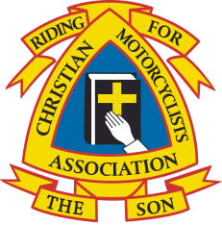
STANDING ORDER FORM
Christian Motorcyclists Association (UK) Ladies
Registered Charity Number: 1080911

To: ………………………………………………………………………………………. (Your bank’s Name)
………………………………………………………………………………………….… (Your bank’s address)
…………………………………………………………………………………………… (Your bank’s postcode)
From: ………………………………………………………………………………... (Your name)
………………………………………………………………………………………….… (Your account name)
……………………………………………………………………………………………. (Your account number)

……………………………………………………………………………………………. (Your sort code)

*Full initials and surname ………………………………………………………………………………………………..
INSTRUCTIONS TO THE BANK: Please include this*as customer’s reference in all transactions. Thank you.

I/We wish to pay a Standing Order to CMA (UK) Ladies as follows:
Account name: CMA (UK) Ladies
Account number: 50627848
Sort Code: 53-50-15
Bank: NatWest,

12-month plan
11 monthly payments of £14.63
1 monthly payment of £14.57
First payment date | 1 October 2021
Final payment date | 1 September 2022
Total payment of £175.50
Personal plan – other
…… monthly payments of £………….
First payment date
Final payment date
Total payment of £175.50

Signed: ……………………………………………………………………………………..

Print Name: ……………………………………………………………………………..

Date: ………………………………………………………………………………………..

Please note: Your deposit of £10 and your personal plan payment £175.50 (total £185.50) must be paid in full on or before the 1st October 2022. Thank you.

